“But if any of you lacks wisdom, let him ask of God, who gives to all generously and without reproach, and it will be given to him.”
-- James 1:5
- Please show all your work! No partial credit will be given for incorrect answers with no work shown. Please draw a box around your final answer.
- Give exact answers to all questions unless otherwise noted.
- Calculators are permitted, but no notes, text, laptops, PDAs, or electronic dictionaries.
- Cell phones should be muted and left in your pocket or bag.
Total marks: 70

Simplify:
- 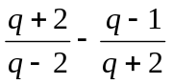 [3]
(7q+2) / (q²-4)
- 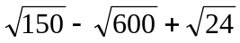 [2]
-3√6
- (0.064)^{-1/3} [2]
5/2
- Rationalize (eliminate the square root in) the denominator: [3]
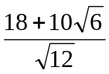
3√3 + 5√2
- 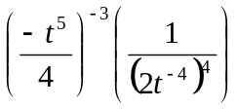 [2]
-4t
- Write the first three terms of the series: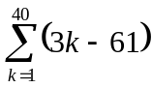 [1]
-58, -55, -52
- Calculate the sum in the previous problem. [3]
(-58+59)(40/2) = 20
Factor:
- d² + 2d – 48 [2]
(d-6)(d+8)
- 3k³ – 5k² – 2k [3]
k(3k+1)(k-2)
- 18p¹¹ – 8px⁶ [3]
2p(3p⁵ – 2x³)(3p⁵ + 2x³)
Solve:
- 2x³ + 3x² = 5x [3]
x = 0, 1, -5/2
- 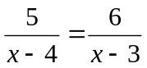 [2]
x=9
- 2h² – 10h + 7 = 0 [3]
h = 5/2 ±(1/2)√11
- 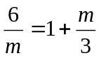 [3]
m=-6, 3
- |x – 3| > 2x [4]
x < 1
(x < 1 or x < -3 is equivalent to
just x < 1)

- The demand curve for a product your business sells is p = 100 – q/300.
  - Calculate p when q=0. Interpret this in the context of demand. [1]
When the price is p=$100,
the product is too expensive and the demand is zero.
  - Calculate q when p=0. Interpret this in the context of demand. [1]
When the product is given away for free,
consumers will take q=30,000 units.
  - Express the total revenue from sales of this product as a function of quantity. [2]
R = pq = (100 – q/300)q
= 100q – q²/300
  - What is the target sales (quantity) that maximizes revenue from this product? What is this maximum revenue? [3]
R = -(1/300)(q – 15,000)² + 75,000
Target sales = 15,000 units
Max revenue = $750,000
  - What price should be set for the product in order to maximize revenue? [1]
p = 100 – (15,000)/300 = $50
  - The supply curve for the same product is given by p = 24 + q/500.
If the price were set in order to maximize revenue according to the demand function, how many units would the supplier be willing to supply?
Would this be an overstock or understock situation? [3]
q = 500(p – 24) = 500p – 12,000
@p = $50: ⇒ q = 500(50-24) = 13,000 units
Less than the 15,000 units demanded, so understock
  - Find the equilibrium point for this system, and the total revenue at equilibrium. [4]
q = 14,250
p = $52.50
R = pq = ($52.50)(14,250) = $748,125
  - At equilibrium, the cost function is C = 90,000 + 49q.
Is there a net profit at this point? [3]
P = R – C = $52.50q – ($90,000 + $49q) = $3.50(14,250) - $90,000
(alternatively: R – C = $748,125 - $788,250)
= -$40,125 profit (loss). No, there is no profit.
- Let 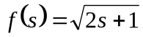 and 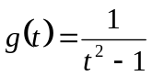.
  - Find the domain and range of f. [2]
Domain: s ≥ -1/2. Range: ≥ 0
  - Find the domain of g. [1]
Domain: t ≠ ±1
  - Find 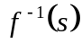. [2]
(s² – 1) / 2
  - Does 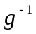 exist? If so, find it. If not, explain why. [2]
No: g is not one-to-one
(sqrt would involve ±)
  - Find 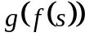. [3]
1/(2s)
  - Describe a sequence of transformations that can be applied to the graph of the function 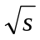 to obtain the graph of 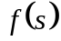. Sketch . [3]
Squash horizontally by a factor of ½,
then shift left by 1.

